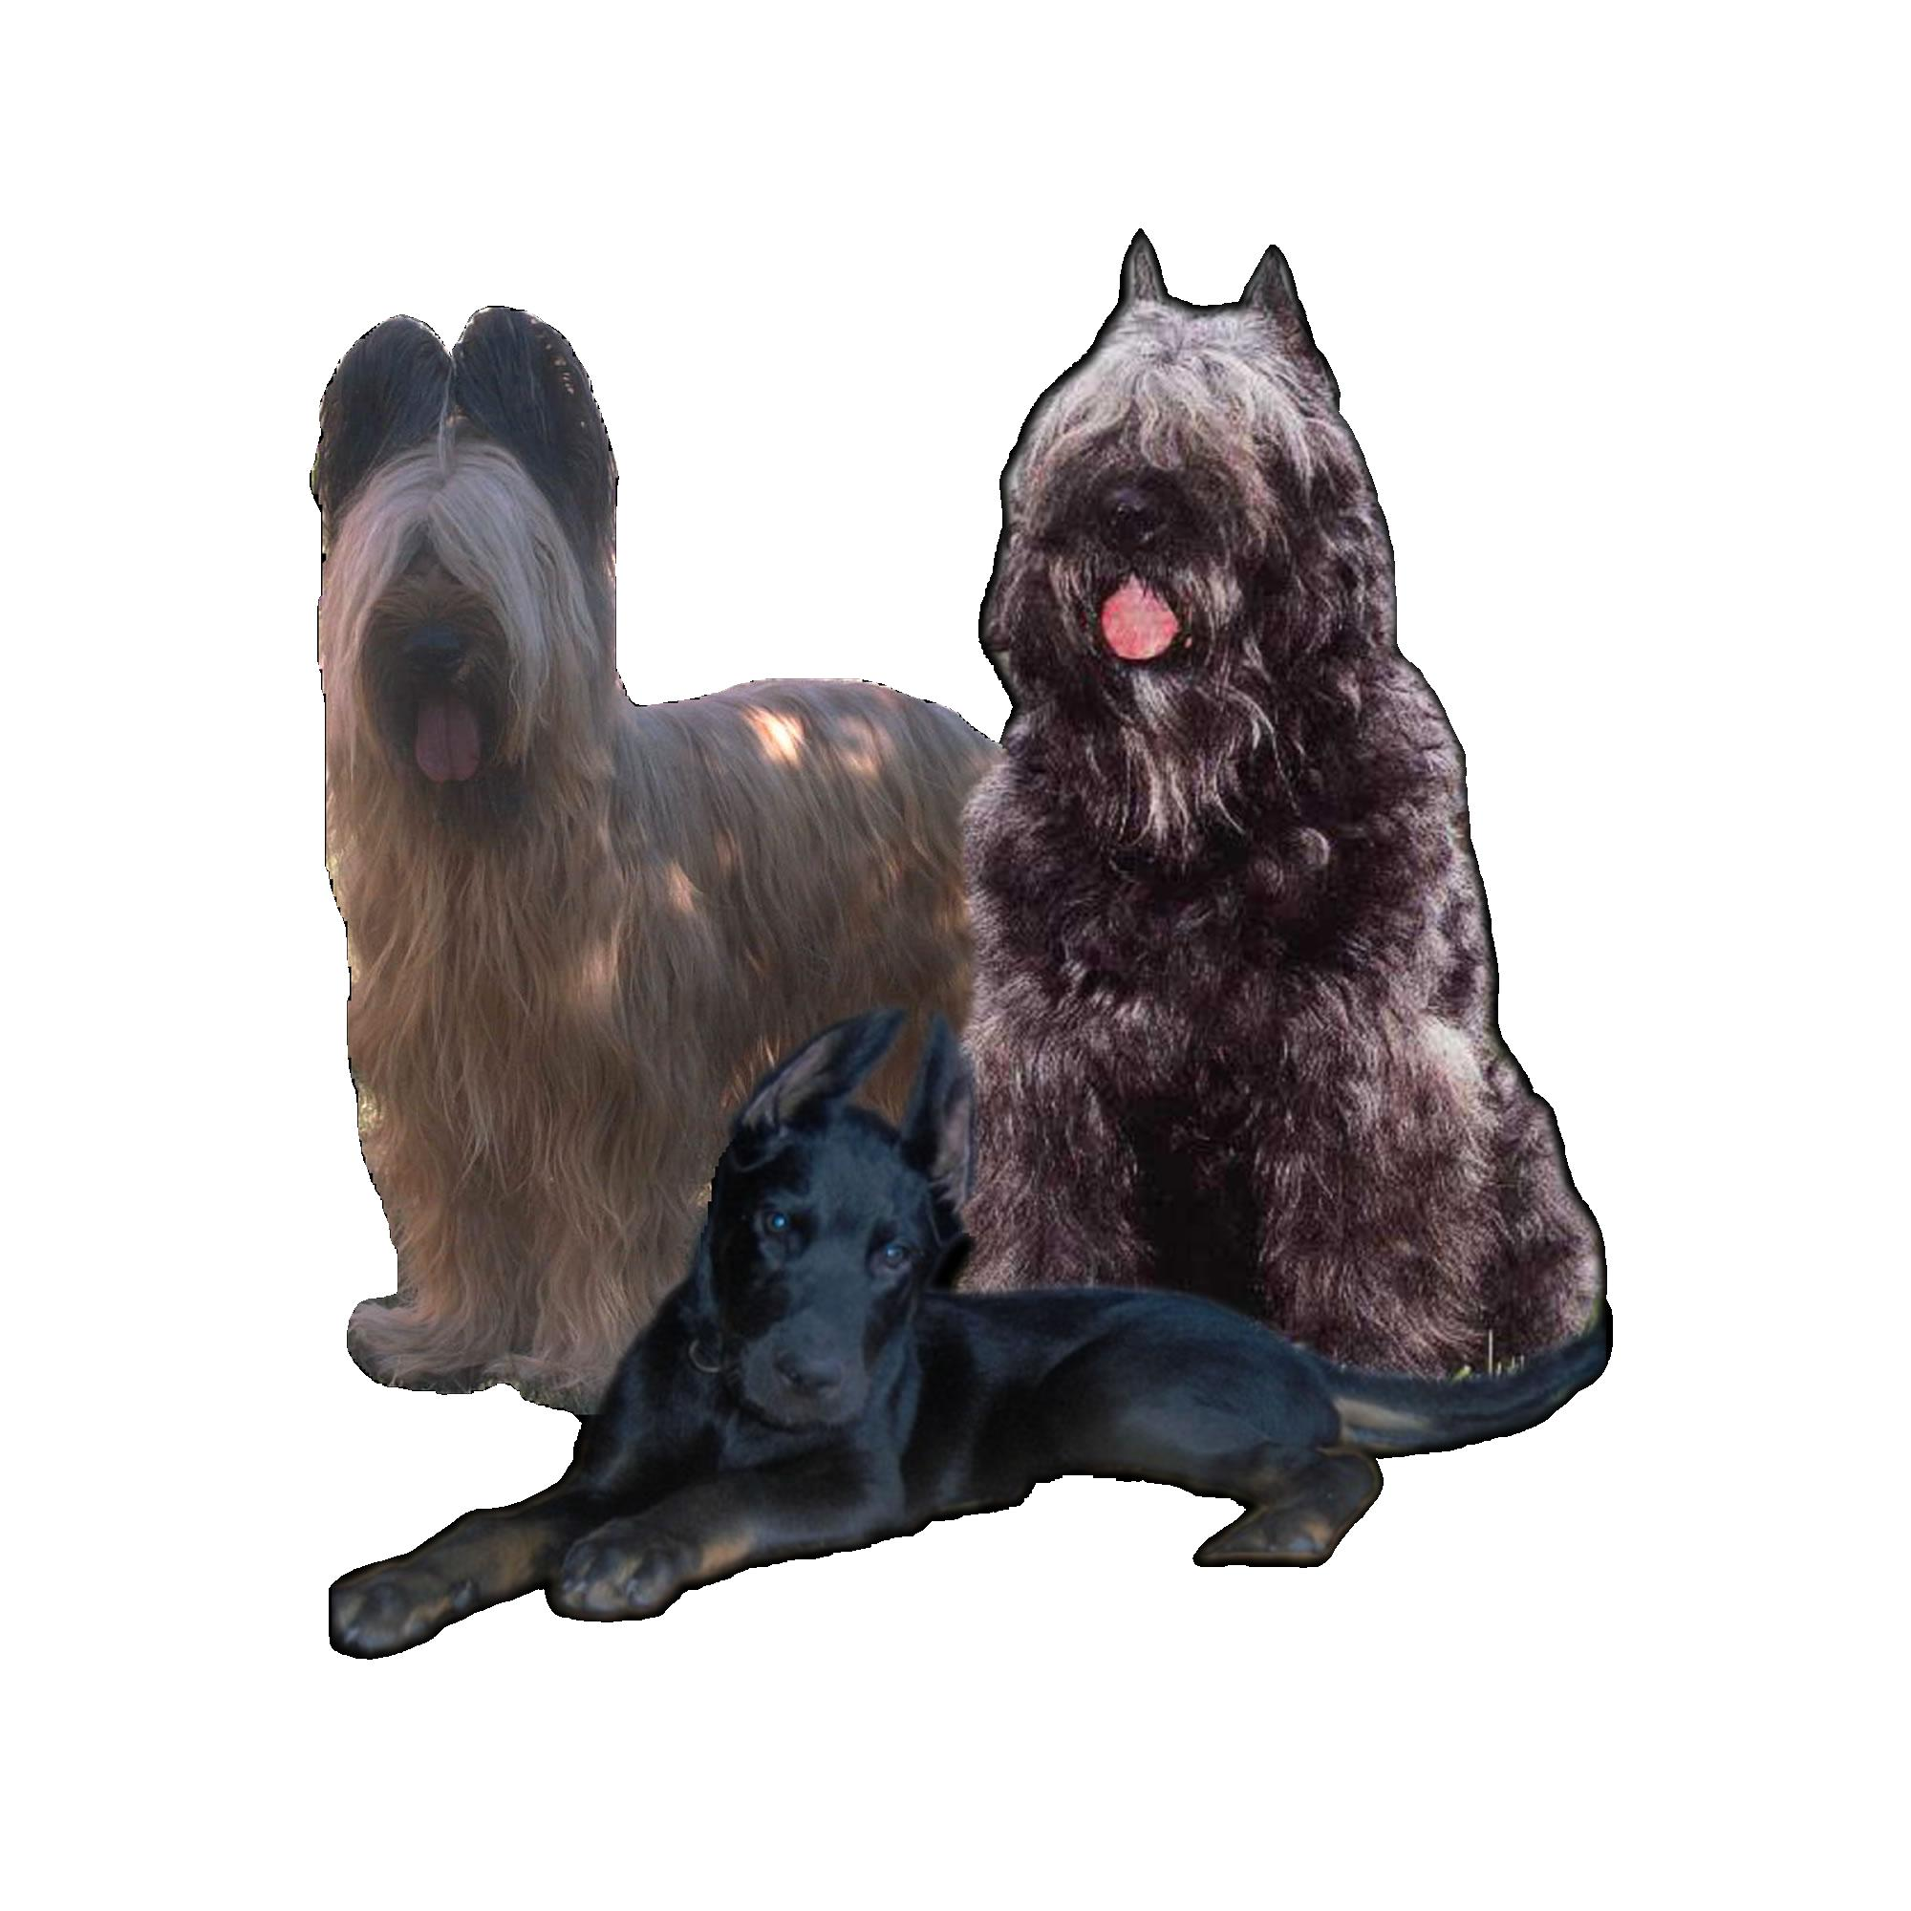
One weekend - One place - Three Dog Show!
Francia Pásztorkutyák Baráti

Köre



S p e c i a l C A C

French Shepherd Show

Judge: Jean-Paul Kerihuel (F)

Date: 14:00 Saturday, 21. October 2006.
Place: Hungexpo, Budapest
(at the same place and time as the CACIB and Central-Eastern European Dogshow on 21-22. Oktober 2006.)
Participant breeds: Berger de Brie, Berger de Beauce, Berger des Pyrénées á face rase Berger des Pyrénées á poil long Bouvier des Flandres, Chien de Montagne des Pyrénées
Entry classes: baby, puppy, young, intermediate, open, working, champion, veteran.
Available entitles: HPJ, CAC, BOB, BOS, BIS, res. BIS

Judge: Jean-Paul Kerihuel (F)
In the case of much entering, the baby, puppy, young and veteran dogs, from the following breeds: Berger de Brie, Berger de Beauce, Bouvier des Flandres, will be judged by Ferenc Gröschl (H).
The rihgt to the change of the judge is reserved.

Entry fees:
* For the first dog with catalogue: 35 EU
* For every additional dog without catalogue: 30 EU
* The entry fee for baby, puppy and veteran classes for each dogs: 20 EU

Registration deadline: 01. october 2006.

Payment: OTP BANK
HU47117200012019271000000000
SWIFT CODE: OTPVHUHB

The payment is also possible on the place of the show before the starting. In this case the registration fee rises with 5 EU.
The fee of the BIS program could be pay on the place of the show.
The entering for the show is possible by any kind of registering page. The registration is practicable before the show only.
For the e-mail registration, the registration page is found on the Internet on the nksz.fw.hu site.
Must enclose or attach to the registration page: For the successful entry to the Champion or the Working Class the copy of the champion or exam certificate have to be send with the registration page, otherwise the dog will be entered to the Open Class automatically.
Every other question is handled by the Show Rules of the Hungarian Kenel Club (MEOE).

Please send your registration to
the following address:

Firle Krisztina
H-2030
Érd
Aradi u.64

or the following e-mail address:

kriszta@desperado-briard.hu
Attention!
The Hungarian Kenel Club (MEOE) organise a two days long CACIB show at the same place and date.
Further information: www.kennelclub.hu

